52 Weekly Practices for 2021

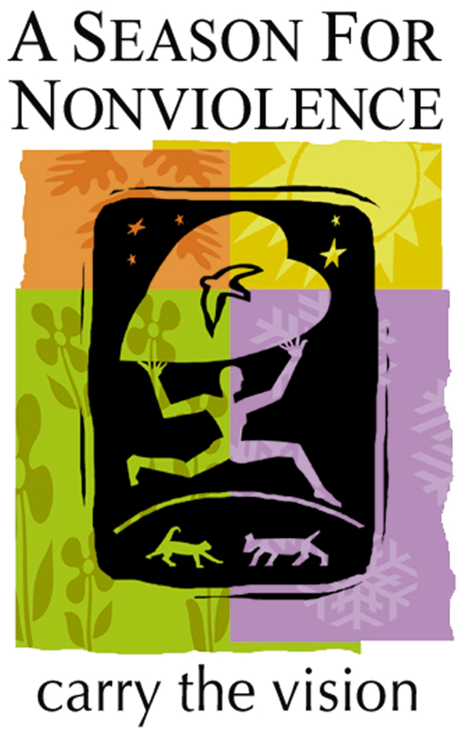
We learn to practice nonviolence one step at a time, one choice at a time, one day at a time. Through our daily nonviolent choices and action, the noble and courageous spirit within each of us expresses itself as the skills, wisdom and character of a nonviolent human being. This is how we each, in our own way, move the world in the direction of peace.
Nonviolence begins by learning how to be less violent and more compassionate towards our own being and allowing that evolving self to act in the world with mature understanding. In learning to speak and act with self-respect, honor, and reverence we find the courage to lift those who are underserved or unrepresented -- in the name of justice for all.

January
Week 1-Prayer, Peace
"Prayer from the heart can achieve what nothing else in the world can," said Gandhi. Begin and end each day this week with a prayer for peace. Let peace begin with you.
An 11-year old writes, "Peace is a special thought or a special love or light or spark that we all share within ourselves." Thich Nhat Hanh wrote, "Practice watering seeds of joy and peace and not just seeds of anger and violence, and the elements of war in all of us will be transformed." Each day this week make a choice to meet each experience with an intention for peace.
Week 2-Harmony, Unity
Choosing not to engage in any form of gossip today contributes to harmony and peace in relationships. Each day this week choose to see the good in others rather than finding fault.
Differences give variety to life and are often only on the surface, anyway. Each day this week look for three ways to see beyond outer differences in opinions, appearances or goals. Find the meeting point of underlying unity that exists in diversity.
Week 3-Believing
Author Wayne Dyer writes about the impact that our beliefs have on our daily lives. Each day this week believe you have all the resources to move your life in the direction of peace. Be aware of simple demonstrations of peaceful responses you receive.
Week 4-Integrity
Do the right thing. Spike Lee used these words as a title for one of his movies. When faced with a choice this week, listen to your conscience. You know what’s right. Do it.

February
Week 1-Self-forgiveness
When you judge yourself, you tend to believe that who you are is what you have or don’t have. Knowing that who you are is greater than all these things, each day this week forgive yourself for forgetting the good that is in you.
Week 2-Love
Gandhi wrote, "Nonviolence is based on the assumption that human nature…. unfailingly responds to the advances of love." Each day this week focus on what you appreciate most about the person you like the least.
Week3-Caring, Compassion
According to Peter McWilliams, "Nonviolence toward the self is caring for oneself. It is what the Greeks call reverence for the self." Real caring is not just what we say, but what we do. Make a list of at least five ways you can take better care of yourself. Practice at least one each day this week.
Mother Theresa implored us to "find someone who thinks he is alone and let him know that he is not." Each day this week do as Mother Theresa suggests.
Week 4-Kindness, Graciousness
Everyday we hear of random and senseless acts of violence. Participate in the counter-revolution of kindness started by Anne Herbert. Perform three random acts of kindness and senseless acts of beauty each day this week.
When you are out driving this week, slow down, and let the other person in front of you. Stop and let pedestrians cross the street.

March
Week 1-Groundedness
Gandhi said, "To forget how to dig the earth and tend the soil is to forget ourselves." And Black Elk said, "Some little root of the sacred tree still lives. Nourish it, that it may leaf and bloom and fill with singing birds." Each day this week place a seed in the earth, plant a tree or nurture an open space.
Week 2-Creativity
The worst thing you can do to a human soul is to suppress its natural desire to create. Identify at least five ways in which you express your creativity everyday. Each day this week, allow something unpredictable and joyous to express through you.
Week 3-Dreaming, Mission
Martin Luther King, Jr. had a great dream. What is your dream for peace? Write it down. What is one thing you can do to honor your dreams? Do it each day this week.
"My life is my message," says Gandhi. Write down what you want to stand for in your life. Note at least one way you can show, through action that you stand for your beliefs. Take action each day this week.
Week 4-Choice
Be aware, this week, of any jokes or remarks that show disrespect toward ethnic groups, women or men, classes or people, religious groups, gays or lesbians. Be considerate of every person’s dignity and choose not to participate in disrespectful conversation.
Week 5-Contemplation, Inspiration
For at least three minutes, each day this week, relax, breathe, and let your mind be fed by "whatsoever is good and beautiful and just." Sacred scripture states, "as a man thinketh in his heart, so is he."
Think of at least two people who exemplify for you the practice of nonviolence. What is it you admire about them? Practice these behaviors each day this week so that other people may be inspired.

April
Week 1-Reverence, Honor
Environmentalist John Muir said, "Everybody needs beauty as well as bread, places to play in and pray in, where Nature may heal and cheer and give strength to body and soul." Each day this week, go for a walk and realize the beauty around, above and below you.
Albert Einstein said, "There are only two ways to live your life. One is as though nothing is a miracle. The other is as if everything is." Before each meal this week, stop and honor all the hands that brought it to you and bless the earth for its bounty.
Week 2-Accountability
In conflicting situations, personal accountability allows us to take responsibility for how we contribute to the conflict. Each day this week, take responsibility for how you contribute to a conflict and make a different choice that can lead to a peaceful resolution.
Week 3-Acceptance
"Resentment, fear, criticism, and guilt cause more problems than anything else," says Louise Hay. Each day this week, choose not to judge yourself (your looks, your capabilities, your expressions.) See all the ways you are unique, loving, capable and bright!
Week 4-Amends
Make amends this week. Apologize to someone you may have hurt and mean your apology, sincerely.

May
Week 1-Forgiveness, Humility
When we forgive, we are free to let go of the past and move on with our lives. We do not condone the hurtful behavior, but we realize there is something within us that is more powerful and important than this wounding experience. This week, write a letter to forgive someone. You do not have to mail it.
Making mistakes is a part of learning and growing, simply an "error in approach." Each day this week, freely acknowledge at least one mistake you make, and reflect for a couple of minutes on what you have learned.
Week 2-Healing
Writer, poet, activist, and professor Maya Angelou turned a traumatic childhood experience into a catalyst for creativity and achievement. This week, choose a painful incident in your life and find the "gift" it has given you. Consciously share this gift with others this week.
Week 3-Understanding
Thich Nhat Hanh says, "When you understand, you cannot help but love…Practice looking at all living beings with the eyes of compassion." Send a silent thought of love to ten people this week. Share your experience with someone.
Week 4-Responsibility
The quality of your community starts with you. Take responsibility for the quality of your community wherever you are. Each day this week, pick up trash that is not your own, whether at home, at the office or on the street. Every little bit helps.
Week 5-Friendliness
To humorist Will Rogers, strangers were simply friends he hadn’t met. View those you encounter this week in that light. Make a new acquaintance.

June
Week 1-Ecology
Value the earth by conserving natural resources and avoiding the purchase of products that deplete the rain forests or exploit labor forces. Practice recycling each day this week by using at least one recycled product or by recycling something.
Week 2-Smiling
Buddhist teacher Thich Nhat Hanh said, "If in our daily life we can smile…not only we, but everyone will profit from it. This is the most basic kind of peace work." Each day this week, share a smile with at least three people, knowing that your smile contributes to peace.
Week 3-Simplicity
To simplify is to invite peacefulness. Think of three ways you can simplify your life and put at least one of them into practice each day this week.
Week 4-Uniqueness
Dale Carnegie says that the greatest need people have is for love and approval. Praise, compliment and honor the uniqueness of at least five people this week. Notice the positive impact you make by valuing the individuality of each one.

July
Week 1-Freedom, Citizenship
Civil rights activist Diane Nash said, "Freedom, by definition, is people realizing that they are their own leaders." Take a leadership role this week in your own life. Find one way you can be more expressive of who you truly are.
Robert Muller, former assistant secretary general to the UN, urges, "use every letter you write, every conversation you have, every meeting you attend, to express your most important beliefs and dreams." Each day this week call or write one of your legislators and register your views.
Week 2-Advocacy, Equality
"When someone stands up to nonviolence," says Thich Nhat Hanh, "a force for change is released. Every action for peace requires someone to exhibit the courage to challenge violence and inspire love." Each day this week be an ally. Without blaming or judging others, speak out for those who are disrespected.
Have you ever noticed the groups of people who are under represented in your activities and lifestyle? Find one way to connect with a person from these groups each day this week.
Week 3-Courage, Disarmament
Eleanor Roosevelt has urged, "You must do the things that you think you cannot do." Practicing these 52 Ways will challenge you to do things that you think you cannot do. Each day this week, light a candle and accept the courage to practice these 52 ways of living nonviolently.
Have a conversation with someone today about what the world would be like if there were no weapons nor any need for them. Imagine such a world.
Week 4-Respect, Openness
Gandhi taught, "Language is an exact reflection of the character and growth of its speakers. Each day this week, respect yourself and others be choosing not to use any profanity or "put downs."
A Turkish proverb says, " He who builds himself a fences, fences out more that he fences in." Each day this week, be open to understanding ideas and people that you have previously opposed.

August
Week 1-Action
"Each of us can work to change a small portion of events and in the total of all those acts will be written the history of this generation," said Robert Kennedy. Each day this week, find a way to make one, small change that will contribute to the well-being of your home, school, workplace or community.
Week 2-Faith
When Cesar Chavez was organizing farm workers, he challenged them to say, "Si, se puede" (yes, it is possible) when they didn’t know how they would overcome obstacles. Each day this week say, "yes, it is possible," even if you don’t know how your goal will be realized. Have faith, and say "it is possible" until you find, or are shown, a way.
Week 3-Patience
According to Cesar Chavez, "nonviolence is not inaction…It is hard work…It is the patience to win." When your plans seem delayed, choose to be patient by identifying at least three ways that you can constructively use this time to support your goal.
Week 4-Mindfulness
If we just act in each moment, with composure and mindfulness, each minute of our life is a work of art. Be aware of the motivation behind your action, the intention behind your words, and the needs and experiences of other people. By doing so, you are making life beautiful for others.
Week 5-Education
Knowledge strengthens your conviction and deepens your wisdom and understanding. Learn about the power of nonviolence by educating yourself. Read an article, periodical or book, watch a video on a subject that relates to nonviolence. Learn about human rights, diversity, ecology, history, and politics, forgiveness, spirituality, peace studies, biographies of heroes and more.

September
Week 1-Dialogue
Marianne Williamson describes a healthy society as one in which "those who disagree can do so with honor and respect for other people’s opinions, and an appreciation for our shared humanity." In the Desiderata by Max Ehrmann, he says, "Speak your truth quietly and clearly, and listen to others." Each day this week, speak up but do not enter into the spirit of argument.
Week 2-Cooperation
When we work together, we are stronger than when we work alone. Each day this week, find one significant way your can cooperate more effectively with the people in your family or workplace, school or community. Do it.
Week 3-Mastery
Labor organizer Cesar Chavez teaches, "If you use violence, you have to sell part of yourself for that violence. Then you are no longer a master of your own struggle." Breathe deeply, silently counting backwards from ten to calm yourself and cool off before your speak or act with impatience or anger. Do this at least once a day this week.
Week 4-Service, Witnessing
Dr. Martin Luther King, Jr. said, "Everybody can be great…because anybody can serve. You only need a heart full of grace and a soul generated by love." Sign up to volunteer a minimum of two hours this month with an organization of your choice. Share your commitment with at least one person.
"We are each other’s bond," writes poet Gwendolyn Brooks. Those who practice nonviolence cannot close their eyes to injustice or cruelty. We are here to be a witness for justice and compassion. Each day this week, be willing to stand up for Truth by your presence, your words and actions.

October
Week 1-Giving
"Practice generosity by sharing time, energy, and material resources with those in need." Clean out your closet, bureau drawers, or garage. Are there things you aren’t using that might be of value to someone else? Each day this week, give away what you are no longer using.
Week 2-Self-sufficiency
People need the dignity of work and the opportunity to provide for themselves and their families. Economic self-sufficiency is a requirement for a nonviolent world. This week, create a job for someone or help someone to find employment (for example, help them with a resume or application, help them make phone calls, dress appropriately, or practice interviewing.)

Week 3-Generosity
Mother Theresa said, "There is a hidden poverty more pervasive than lack of money. It is the poverty of the heart." Find three ways to generously give of your time, attention and resources to others.
Week 4-Committment
Spend five minutes each day this week reflecting on your commitment to nonviolence. Write down what it means to you and what you are willing to do as a consequence of your commitment to it. Make your commitment public by sharing it with at least two people.

November
Week 1-Acknowledgement
Tell someone, each day this wee, what a difference he or she has made in your life. Acknowledge that person for being there for you. Make this a week when you don’t take people for granted.
Week 2-Appreciation
Louise Hay says, "Praise yourself as much as you can…The love in our lives begins with us…Loving yourself will help heal this planet." Write down 10 things that you appreciate about yourself. Read aloud what you have written.
Week 3-Thanksgiving, Gratitude
On her show, Oprah Winfrey frequently promotes the daily practice of gratitude. Begin each day by listing five things for which you are grateful and end it by sharing with one person all the of the good in your life each day this week.
Week 4-Praising
Appreciation helps people grow and lets them know that they matter. Offer praise to at least three people this week, for their personal qualities, achievements, or helpful service.
Week 5-Release
A Sufi proverb says, "When the heart weeps for what it has lost, the spirit laughs for what it has found." Each day this week look back on how far you have come during this 52 week journey. Release the weight of your past, judgments of yourself and others, and the idea that world peace is not possible by acknowledging that you do make a difference.

December
Week 1-Intervention
Alcohol and drug abuse is both a consequence and a cause of violence. This week have the courage to intervene in a caring way with someone who is using alcohol or drugs. Through your honest and straightforward communication, encourage them to get educated, get help, and get sober and free from drugs.
Week 2-Listening
Each day this week, stop what you are doing and take five minutes to listen to the feelings behind someone’s words to you. Be fully present for the conversation and interested in what the person is saying.
Week 3-Celebration
Each day this week, rejoice in the work that you have done. Celebrate the journey that you have made with countless others who believe that every individual can move the world in the direction of peace with their nonviolent choice and action. "Never doubt that a small group of thoughtful, committed citizens can change the world. Indeed, it is the only thing that ever has." Margaret Mead.
Week 4-Peace
An 11 year old writes, "Peace is a special thought or a special love or light or spark that we all share within ourselves." Thich Nhat Hanh wrote, "Practice watering seeds of joy and peace and not just seeds of anger and violence, and the elements of war in all of us will be transformed." Each day this week, make a choice to meet each experience with an intention for peace.

